#1

1. a + s = 400

6a+4s=1750

b)  =

c) a=75, s=325

d)

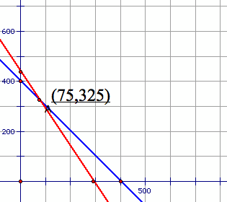

e) By plugging answers into original equations, you could verify the result.

#2

1. x+y=65

20x+25y=1500

b) = x=25, y=40

c) Method such as graphs or tables

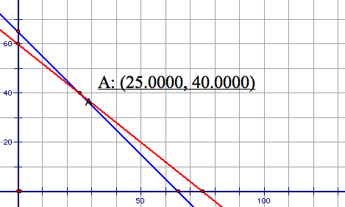

#3

a) 

T S T S

b)  =

c) =

d) T=15

S=20

e) 6T+ S=110

4T+2S=100